

|  |  |
| --- | --- |
| HUMAN RESOURCE MANAGEMENT Submitted to: Mam Tehmina Khan  Submitted to: Mam Tehmina Khan | semester project:  We have chosen a company of Certified Magento Developers who design and create websites.  Members:  Amara Khan (Group Leader)  Roll no. 359  Ahmad Ali  Roll no. 340  Abdul Ahad  Roll no. :349  Ariba Adnan  Roll no. 401  Shoaib Abdullah  Roll no. 380  Shah Ameer  Roll no. 006  Huzaifa Niaz  Roll no. 364 |



It’s a company of certified MAGENTO developers who create budget friendly and professional websites that grab the attention and are conversation friendly. There are about

50 magento experts in the company.

Our visit to ESPARKS was an eye opening experience. The company's human resource management process is well thought out and executed, but it's also very data driven. This makes sense considering the nature of their business—they're in the business of managing people, and they need to be able to make decisions based on facts, not just hunches.

**Address:** Office no 812, Al Hafeez Heights, Main Boulevard Gulberg 3, **Lahore**, Punjab, Pakistan.

**Contact: 0333-4033770**

**Email address:** [**hello@esparksinc.com**](mailto:hello@esparksinc.com)

**Website:** <https://esparksinc.com>

Table of Contents

1. Introduction 5

2.Planning 10

2.1 Problems during manpower planning 11

2.2 Hr supply forecast 13

2.3 Factors affect manpower planning 13

2.4 Whole planning process in E-sparks organization 14

2.5 Importance of planning for E-sparks 16

2.6 Why some Managers fail to plan 19

2.7 Assumptions and Dependencies 20

3. Organizing 21

3.1 Importance of Organizing 21

3.2 What steps are followed while organizing? 21

3.3 What an HR manager considers? 22

3.4 Accessing skills of each team member 22

3.5 Allocating resources for a task 24

3.6 Identifying areas of incapability before assigning work 24

3.7 Assigning roles and responsibilities to individuals 24

3.8 Considering the individual’s abailibility for a task 25

3.9 Considering an individual’s interest for a task 25

3.10 Setting expectations and timeline for completion of task 25

3.11 Support and guidance throughout project 26

3.12 Job rotation 26

3.13 Audit trail 26

3.14 Importance of assigning tasks to appropriate employees 26

3.15 Delegating authority and decisioin making authority 27

3.16 Things HR manager consider while delegating authority 27

3.17 Steps to follow while delegating authority 28

3.18 Importance of delegating authority to the right person 28

3.19 Creating an organization structure 29

3.20 Developing policies and procedures 33

3.21 Importance of developoint policies and procedures 33

3.22 How do HR managers of E-sparks set goals? 36

3.23 Monitor the progress of future goals 37

4.Staffing 38

4.1 Importance of staffing 39

4.2 Methods of staffing 40

4.3 Selection process 41

4.4 Recruiting technologies 42

4.5 Factors affecting staffing 42

4.6 Why careful selection is important 44

References 45

**INTRODUCTION**

E-Sparks was started 5 years ago with a clear dream of becoming a trustworthy company among the e-commerce realm for Magento development services.  Until now, E-Sparks has worked for many reputed clients and catered to their needs with the hard work, passion, and dedication of the Magento development team in providing quality results. In the upcoming years, E-Sparks aims to grow and expand its horizons while leaving a positive impact on society by promoting core values like integrity, transparency, inclusiveness, and fulfilling corporate social responsibility.

**Who are E-Sparks?**

**“E-Sparks Create Revenue-Generating Magento Ecommerce Websites”**

We are one of the best Magento Website Development Companies with years-long experience. We provide all kinds of services required to develop and grow your e-commerce business. From providing consultation to delivering solutions, our team of experts is always ready to assist. Make us a part of your team and bring your Magento stores to life, from ground Our Magento Development and Design teams work together to build a healthy, open, and creative environment. We believe that aesthetics are as important as functionality, and this is why we do our best to give equal attention and time to both. Best customer services and uncompromisable quality is our strength. We pay equal attention to each of our clients and deliver the best and highly competitive business solutions. We provide custom strategies to our clients based on their business needs and goals.

### Message from the CEO

### 

E-Sparks, my brainchild, started with an intent of becoming the most trusted and sought-after E-commerce Development Company in the region with a vision of merging technology and innovation, and to provide e-commerce solutions under one umbrella from startups to small and large enterprises. However, despite having high-end technological expertise at the nucleus of it, I always ideated strong moral and ethical values to be at E-Sparks core.

I envision a workplace where employees compete in a healthy environment, a place that renders togetherness, positivity, autonomy, and professionalism. Assuring my team with an experience rather than just a mere workspace, where they feel motivated and driven to show up each day and make the most of it. We love to lead by example and show excellence in everything that radiates strong purpose and direction amid team members.

We have been fortunate that our hard work came to fruition in such a short span of being in the market and working with some of the most amazing clients who have become a significant part of E-Sparks family now. It was their trust in us that drove us to outperform for them. E-Sparks has seen a remarkable growth in these 5 years. We believe in absolute transparency to our clients and that is why they rely on us for all their tech needs, which is evident through their loyalty and commendations.

We take pride in being diligent towards our corporate social responsibility, by enabling ample job opportunities, embracing diversity and gender balance. Our objective is to grow by multifold, adding talented, reliable, and brilliant minds to our family and expand to work on several other frameworks as per the increasing and diversifying market demand. We want to mark our existence as a company that creates a long-lasting and positive impact on the well-being of society.

**Achievements:**

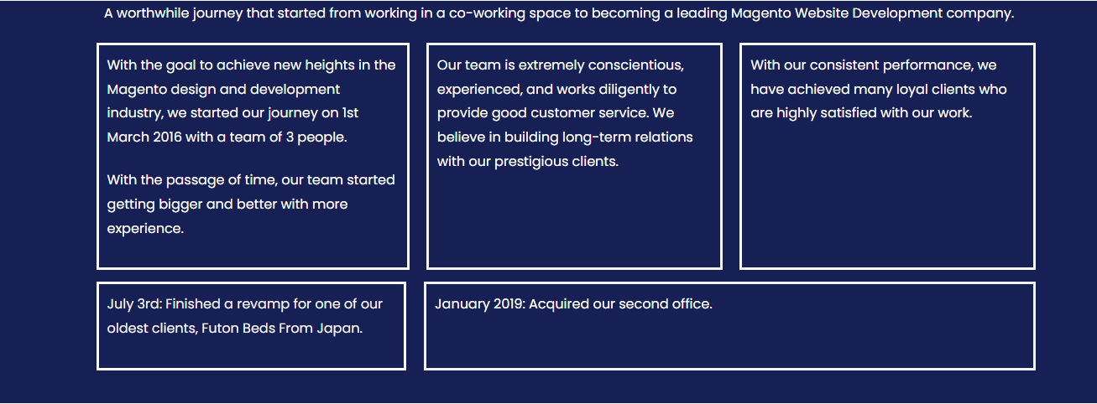

**ABOUT ESPARKS DEVELOPMENT:**

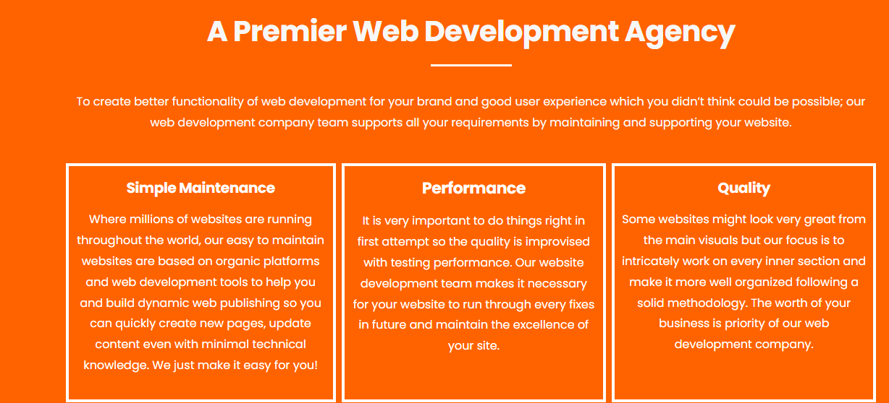

**SERVICES:** 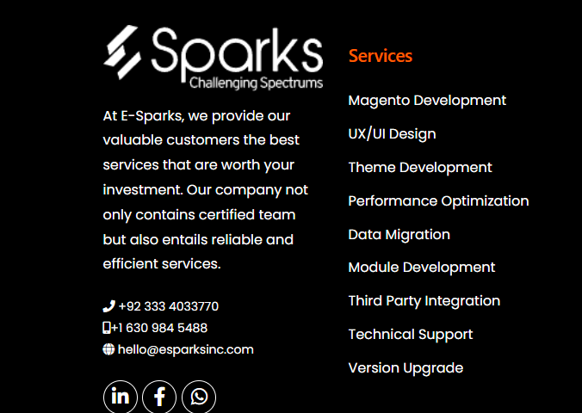

**CERTIFICATIONS WHICH E-SPARKS HAVE:**

**About their Human Resource Management:**

We were impressed by how much data they have access to. They've got a database of all employee information, including job title, location and hours worked per week, skills and experience acquired over time at ESPARKS, and even information about any previous employers that an employee has worked for before joining ESPARKS!

They also have a real-time system for tracking performance reviews (and giving feedback) on each employee based on their behaviour and performance during their shift. This allows them to see which employees are doing well or poorly in their jobs at any moment in time—and then adjust accordingly!

All together this is an approachable company with great systems in place for managing people effectively.

They had a clear process for hiring and firing employees, including a clear hierarchy of supervisors and managers.

It was also clear that they paid close attention to the work environment that they provided. Their office was very clean, organized and well-ventilated.

The training process seemed very thorough and involved all levels of employees in class discussions. This helped create an inclusive environment where everyone felt comfortable speaking up when they disagreed with something being taught or said by one of their superiors.

Finally, their benefits package seemed quite generous and provided many benefits including: health insurance, dental insurance, life insurance, disability insurance and more.

The ESPARKS team was very welcoming, and I had a great time meeting everyone. They're a young company and have just recently expanded into the Pakistan’s market, so they're still working out some of the kinks in their process. However, their human resource management system is well-designed and easy to work with. The team at ESPARKS seems to be very invested in the employee experience, which is something that's hard to find within the start up space.

The company ESPARKS has an efficient human resource management system. This system is made up of three steps: recruitment, training and appraisal. The first step is to recruit employees who are suitable for the job. The second step is to train them on the job so that they can perform at their best. The third step is to evaluate their performance and give them feedback on how they have performed. This system helps ESPARKS to maintain a high level of productivity and efficiency.

The company, ESPARKS, has implemented steps to control human resource.

The first step is the establishment of a formal human resource policy and procedure manual. This manual establishes the policies and procedures for hiring, firing, evaluating employees, and providing benefits. The policy manual also includes information about how to manage the employee's performance appraisal process.

The second step is to establish an effective performance management system that ensures employees have clear expectations of their responsibilities and goals. The performance management system should be designed to provide feedback on each employee's performance so that they can improve as needed.

The third step is to provide training so that every employee understands their job duties and specific responsibilities at all levels within the organization. The training program should include specific instruction on how employee responsibilities are carried out in order to ensure that everyone operates at peak efficiency within the company's policies and procedures.

The steps taken by ESPARKS for controlling human resource are as follows:

1) The first step is to hire the right people for the job. This means that the company needs to make sure that they are hiring people who will be able to do the job well and who will be a good fit for the company culture.

2) The second step is to develop a good relationship with those employees. This means that the employees should feel like they have a place in the company and that they are respected and valued by their supervisors and co-workers.

3) The third step is to provide training and development opportunities for all employees. This helps them grow personally, professionally, and emotionally at work through classes or seminars on topics such as management skills or new technologies being used in the industry.

4) The fourth step is to focus on employee retention through programs such as bonuses or benefits packages which can help keep people around longer than they might otherwise stay at another job where they feel less appreciated or rewarded for working hard every day!

**2. PLANNING**

Organization and planning help you do your job correctly, avoiding costly mistakes. Organize your work and plan ahead to help you work more efficiently and productively.

We visited the E-sparks Company and their HR Manager told the following steps for Planning.

* Recruitment planning should reflect the company's strategic plans. So planning to enter new businesses or cut costs affects all kinds of positions that you need to fill.
* Strategic issues are always decisive.
* In the short term, there is little employers can do to weather an economic downturn, or increase or decrease in consumer spending.
* However, the managers should control their strategy.
* For example, learning that a company plans to expand internationally means making plans to increase the number of employees in the company's international department.
* A basic workforce planning process is to forecast an employer's labour demand and supply. We then identify gaps between demand and supply and develop an action plan.

**2.1 Problems during manpower planning**

The process of deciding how many people will be needed for a particular job or project, and how they should be used. Manpower planning consists of putting the right number of people and right kind of people in the right place to achieve the organizations goal. Because hiring people again and again is costly we have to give training to the every new employee and have to make sure they do not leave during the project because in case of that we will face difficulties. And have to hire a new employee in place of that employee which is not free of cost.

Human Resource Planning has to be a systems approach and is carried out in a set procedure. The procedure is as follows:

1. Analysing the current manpower inventory
2. Making future manpower forecasts
3. Developing employment programmes
4. Design training programmes

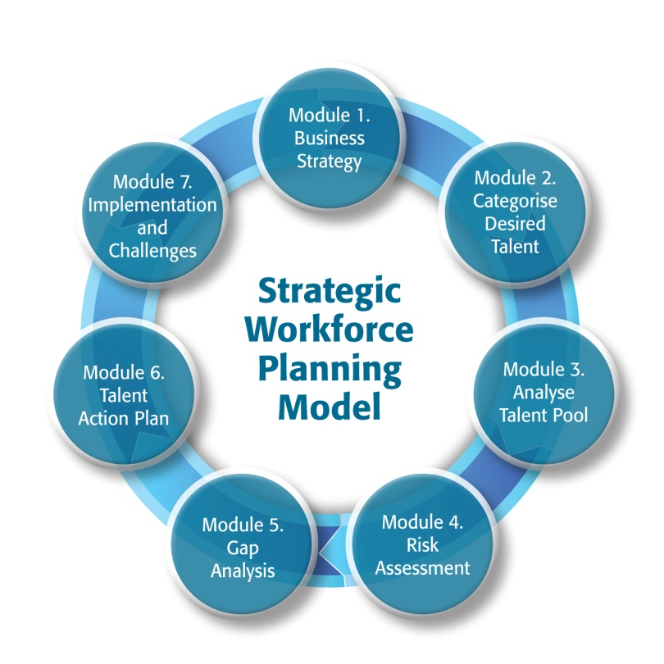

1. **Analysing the current manpower inventory**

Before a manager makes a forecast about the future workforce, it is necessary to analyze the current state of the workforce.

For this the following things have to be noted.

* + Type of organization
  + Number of departments
  + Number and quantity of such departments
  + Employees in these work units

Once these factors are registered by E-sparks manager, he goes for the future forecasting.

1. **Making future manpower forecasts**

Once the factors that influence future workforce projections are known, it is possible to plan for future workforce needs across multiple units of work.

The Manpower forecasting techniques commonly employed by the E-sparks organization are as follows:

**Expert Forecasts:** This includes informal decisions, formal expert surveys and Delphi technique.

**Trend Analysis:** Manpower needs can be projected through extrapolation (projecting past trends), indexation (using base year as basis), and statistical analysis (central tendency measure).

**Work Load Analysis:** It is dependent upon the nature of work load in a department, in a branch or in a division.

**Work Force Analysis:** Whenever production and time period has to be analysed, due allowances have to be made for getting net manpower requirements

.

**Other methods:** Several Mathematical models, with the aid of computers are used to forecast manpower needs, like budget and planning analysis, regression, new venture analysis.

1. **Developing employment programmes**

After current figures are compared with future projections, employment programs can be developed and developed accordingly, including recruitment, selection procedures and placement plans.

1. **Design training programmes**

These will be based on diversification, expansion plans, development program, etc. The training programs depend on the level of technological improvement and the progress achieved. It is also done to improve the skills, abilities, knowledge of the workers.

**2.2 HR supply forecast**

HR forecasting is the process of predicting demand and supply whether it’s the number of employees or types of skills that are needed and available to get the job done. Basic forecasting techniques include: yearly sales or production projections.

**2.3 Factors affect manpower planning**

Human resource planning is susceptible to a number of factors and thus needs intricate understanding of the same for an efficient result. Some of the major factors affecting Manpower planning are the ones that follow-

**1. Organizational Structure**

E-sparks foundations (departments, functions, etc.) play a central role in assessing staffing requirements for the tasks to be performed.

**2. Growth and Planning**

E-sparks development can have a huge influence on HRP as the internal growth of individuals must also be considered in order to keep up with the development.

**3. Business Location**

The location of the business is an important factor because areas with a lack of job opportunities attract people more easily than areas with lots of options.

**4. Demographic Changes**

Demographic change refers to changes in age, population, workforce composition, etc. While some people retire each year, a new batch of specialist graduates graduate each year, which can change the structure of the business.

**5. Environmental Uncertainties**

Political, social and economic uncertainties must be taken into account when formulating policies and programs for recruitment, selection, training and development.

**6. Expansion**

Future expansion should be considered to determine the creation of new positions and the potential of existing workers to accommodate developments and strategies to prepare them.

**2.4 Whole planning process in E-sparks Organization**

The organizational planning process includes five phases that, ideally, form a cycle.

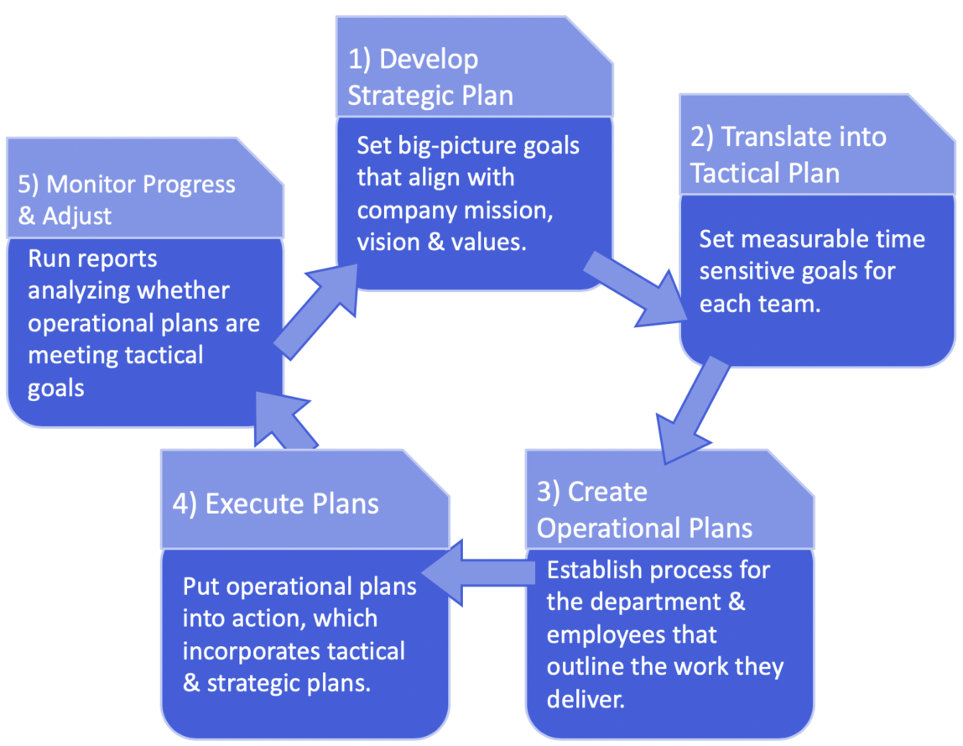

Strategic, tactical, operational, and contingency planning fall within these five stages.

1. **Develop the strategic plan**

Steps in this initial stage include:

* Review your mission, vision, and values
* Gather data about your company, like performance indications metrics from your sales department
* Perform a SWOT analysis: takes stock of your company’s (strengths, weaknesses, opportunities, and threats).
* Set big picture goals that take your mission, vision, values, data, and SWOT analysis into account

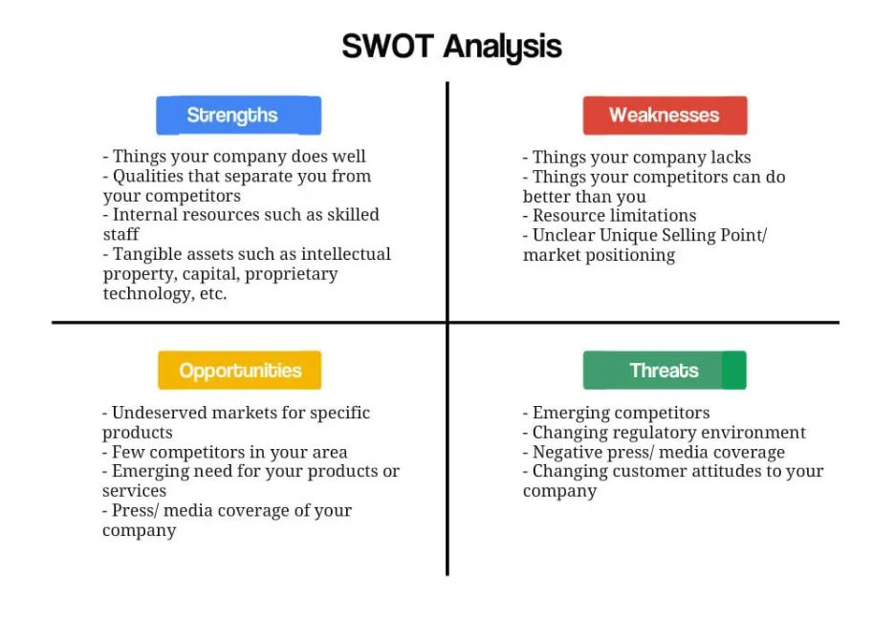

1. **Translate the strategic Plan into tactical steps**

At this point, it’s time to create tactical plans, Bring in middle managers to help do the following:

* Define short term goals quarterly goals are common that support the strategic plan for each department in E-sparks, such as setting a quota for the sales team so they company can meet its strategic revenue goal
* Develop processes for reviewing goal achievements to make sure strategic and tactical goals are being met, like running a CRM report every quarter and submitting it to the chief Revenue Office to heck that the sales department is hitting its quota
* Develop contingency plans, like what to do in case the sales team’s CRM malfunctions or there’s a data breach

1. **Plan daily operations**

Operational plans, or the processes that determine how individual employees spend their day, are largely the responsibility of middle managers and the employees that report to them. For example, the process that sales rep follows to find, nurture, and convert a lead into a customer is an operational plan. Work schedules, customer service workflows, or GDPR policies that protect prospective customers information all aid a sales department in reaching its tactical goal in this case, a sales quota so they fall under the umbrella of operational plans.

This stage should include setting goals and targets that individual employees should hit during a set period.

Managers may choose to set some plans, such as work schedules, themselves. On the other hand, individual tasks that make up a sales plan may require the input of the entire team. This state should also include setting goals and targets that individual employees should hit during a set period.

1. **Execute the plan**

It’s time to put plans into action. Theoretically, activities carried out on a day to day basis defined by the operational plan should help reach tactical goals, which in turn support the overall strategic plan.

1. **Monitor progress and adjust plans**

No plan is complete without periods of reflection and adjustment. At the end of each quarter or the short term goal period, middle managers should review whether or not they hit the benchmarks established in step two, then submit data, backed reports to C-level executives. For example, this is when the manager of the sales department would run a report analyzing whether or not a new process for managing the sales pipeline helped the team reach its quota. A marketing team, on the other hand might analyze whether or not their efforts to optimize advertising and landing pages succeeded in generating a certain number of leads for the sales department.

Depending on the outcome of those reviews, E-sparks may wish to adjust parts of its strategic, tactical, or operations plans. For example, if the sales team didn’t meet their quota their manager may decide to make changes to their sales pipeline operational plan.

**2.5 Importance of Planning for E-sparks**

1. **Helps you set the right goals**

A plan is both a means to reach your goals and supports SMART goal setting. Planning, in particular, helps critically consider the feasibility of goals. Facilitate decision-making and help companies predict and set timeframes for when they will be able to reach their goals. It also defines how performance will be measured against established targets and who is responsible for it.

1. **Set goals and standards to control**

The primary function of strategic formal planning is to provide direction to lower-level managers and enable the development of tactical objectives. Plans show goals for each organizational unit and help managers prioritize activities according to their relevance to goals.

The plan also sets the criteria for performance evaluation. Without such standards, managers are unable to intervene and take corrective action to stay on track, potentially jeopardizing goals.

1. **Reduce uncertainty**

Uncertainty about the future poses great risks to a company's sustainability, as change is always difficult to manage. No organization can control the economic and competitive environment. Therefore, the ability to anticipate challenges and develop contingency plans is the best option.

Planning involves a deliberate critical assessment of available data and expert projections. Planning in management is therefore very helpful in reducing future uncertainty and avoiding risks.

1. **Eliminate unnecessary duplication of work**

An effective plan clarifies the responsibilities and expectations of each department, team, and even each team member. This will prevent duplication of activities and improve coordination.

At the same time, it helps you determine which activities are wasteful and do not contribute to achieving your goals. Eliminating these activities not only reduces waste and saves valuable time and resources, but also increases productivity and motivation.

1. **Ensure efficient use of resources**

Planning ensures that human and material resources are used as efficiently as possible. Many cost-saving opportunities can be identified by starting the management process with a proper plan that focuses on the end goal and takes into account available skills.

Without such a plan, it's easy to fall for his attractive B2B offers. This wastes organizational resources on raw materials that a worker cannot process in time, expensive robotics, or online software that only speeds up one aspect of the process for him without impacting the overall bottom line. There is likely to be.

1. **Promote innovation**

When E-sparks has challenging goals on the one hand and potential hurdles or market shifts on the other hand, start brainstorming creative ideas and solutions. Determining future course of action is an important function of management. By focusing on the need to achieve goals, employees or managers can identify new opportunities for business development, propose new products and services, or discover new target markets. In this way, planning becomes an ongoing process that fosters creative strategic thinking and innovation.

1. **Improve decision making**

Planning improves decision making and time management in two ways. First, it helps managers focus on a goal and ask how a different course of action might make it easier or slower to reach that goal. Second, the plan allows managers to be more proactive.

With a clear roadmap, you can consider how decisions taken will affect long-term tasks and activities.

Without such a plan, managers' decisions may be non-strategic and based solely on available data and the current situation.

1. **Increase motivation and team spirit**

It is a well-known fact that people are more engaged and motivated when they understand the relevance of their work. A plan shows the relationship between individual inputs and the larger goals they help achieve.

It also shows that everyone in the business environment is essential to achieving common goals. This helps reduce internal competition and promote community and team spirit. You can use motivational quotes for words of encouragement to inspire your team.

1. **Helps to earn credibility and trust from stakeholders**

All managers understand that enlisting the help of creditors and investors requires solid planning. But sometimes we forget that turbulent market conditions can create the need to get involved without planning. Having a formal business plan in place can make a big difference when you need to find and engage new investors in a short period of time.

Having clear goals and a formal plan demonstrates social responsibility and builds trust among employees and customers.

1. **Provides a competitive advantage and enables strategic positioning**

Planning includes a realistic assessment of the company's strengths and weaknesses and identification of competitive gaps and weaknesses. Acting on this data, rather than lazily performing the same actions, can significantly increase your competitive edge.

In addition, planning helps discover growth markets and bring new products and services to market faster than other competitors, giving you a first-mover advantage.

**2.6 Why Some Managers Fail to Plan**

Planning is a basic administrative function, but in practice it is ignored by many administrators. They may think they don't need a formal type of planning because they can use their strategic vision and intuition to keep the organization on track. The main reasons managers do not create strategic plans are:

* **They underestimate the importance of planning**

Many managers have a get things done attitude and are unable to stop and analyze the right things they should be doing. They don't understand how the plan affects performance and don't want to change.

* **I don't have time to make plans**

Planning takes too much time and managers have too much responsibility. So it's common for managers to think only about strategic planning at home or on their way to work. This can lead to planning errors. Managers should plan their plans intentionally. If finding time for this role is difficult, managers should delegate more responsibility and avoid micromanaging.

* **They don't have the necessary knowledge**

There are many tools used for planning, such as SWOT analysis, PESTLE analysis, VRIO framework, environment scan, resource analysis. If managers do not have adequate training in management, they will not be able to plan and see effectively and it will be meaningless. They may also lack experience in certain areas. Creating a marketing plan is very different from an operational plan.

* **They rely too much on their own experience**

Some managers lead us to believe that we could have succeeded without planning and that planning is a waste of time. They attribute their success to their abilities rather than to favourable conditions.

* **They lack self-discipline**

Setting and pursuing personal or organizational goals requires dedication and discipline. Managers often need to develop their personal strengths and skills in order to develop an effective management plan.

* **You have no meaningful goals and objectives**

Managers sometimes avoid planning because there are no goals to plan for or motivate them. This is common in companies that don't have a mission statement.

**2.7 Successful Strategic Planning**

1. **Engagement**

Planning is an administrative function, but behind closed doors he should not be executed by one person. Instead, it is the leader's job to make planning a collaborative and inclusive process. Make employees feel involved in the planning process. Employees are happy to support the plan and share responsibility for its implementation. They may have innovative ideas that you would have missed.

1. **Data, not assumptions**

We all have assumptions about companies and markets that aren't always true. Planning based on assumptions is a grave mistake that negates all the benefits of good planning. Do market research, hold focus groups, talk to your own employees, and consult market experts. Gather all the information that will help you make decisions based on data, not assumptions.

1. **Communication**

Clearly communicating desired outcomes and strategic plans to employees is critical. Maintain open communication and encourage everyone to provide feedback and suggest improvements to the plan. The benefits of a plan, especially innovation, depend on how enthusiastic employees are in voicing their ideas and whether they feel heard and valued when they bring them up. Please be careful.

1. **Culture of Growth**

A true focus on improving efficiency and growth can only be sustained in a culture that values ​​efficiency and growth. Strive to create such a culture within your organization. When you help employees learn and develop skills, measure and reward their personal achievements, they are more willing to commit to ambitious goals and ambitious plans.

1. **Commitment to Change**

Effective planning requires letting go of outdated processes, rethinking strategies, innovating, hiring and firing. All of these represent hard-to-manage changes. However, to truly reap the benefits of scheduling, managers must be willing to face their team's frustrations beyond cosmetic changes. In this regard, planning in management is a function that requires great courage and commitment.

**3. ORGANIZING**

Organizing in human resource management is the process of creating a structure of roles and responsibilities within an organization. This includes determining the number of roles needed, who will fill those roles, and how they will be structured. It also includes setting up systems and procedures to ensure that the roles are filled, tasks are completed, and resources are allocated efficiently. The goal of organizing is to create an environment that allows the organization to operate at its highest level of effectiveness.

**3.1 Importance of Organizing**

Organizing in human resource management is a critical component of a successful organization. It helps ensure that tasks are divided and delegated appropriately, that resources are allocated efficiently, and that goals and objectives are met in a timely manner. Additionally, it helps to increase productivity, reduce costs, and improve morale among employees.

Organizing in human resource management is the process of assigning tasks and responsibilities to employees, creating a structure of roles and relationships, and establishing clear lines of authority and communication within the organization.

Organizing in HRM Process is important for the following reasons:

**1. Establishes Authority:** Organizing helps to establish authority and responsibility for each position in the organization. It defines who reports to whom and the scope of each position’s authority.

**2. Enhances Communication:** Organizing helps to create effective communication channels by outlining the chain of command and the reporting structure. This helps to ensure that the right information is communicated to the right people in a timely manner.

**3. Enhances Efficiency:** Organizing enables the organization to more efficiently use its resources and to make more effective use of its personnel. It ensures that the right people are in the right positions and that tasks are organized in a way that maximizes efficiency.

**4. Promotes Collaboration:** Organizing promotes collaboration by creating a structure that encourages cooperation between different departments and personnel. This helps to ensure that everyone is working together for the common goal of the organization.

**5. Facilitates Decision Making:** Organizing helps to make decision-making more efficient by ensuring that the right people are involved in the decision-making process. It also ensures that the decision-making process is clear and that everyone is informed of the decision.

**3.2 What steps are followed while organizing?**

HR Manager of **E-Sparks** explained the organization structure of the company and elaborated the following steps:

* Identifying the tasks that need to be done
* Assigning roles and responsibilities to individuals
* Delegating authority and decision-making authority
* Creating an organizational structure
* Developing policies and procedures
* Setting goals and objectives and monitoring progress.

All of the above mentioned steps are followed in order to make sure that tasks are assigned to the right people, that the roles and responsibilities are clearly defined and understood, and that there is a clear chain of command and accountability. The organization must also ensure that the organizational structure is flexible enough to accommodate changes in the organization's goals and objectives, and to respond to changes in the external environment.

Organizing ensures that the organization is able to effectively utilize its resources, and that it is able to achieve its goals and objectives in a timely and efficient manner.

**3.3 What an HR Manager Considers?**

HR manager considers following things while organizing:

• The organization’s current and future needs

• The organization’s goals and objectives

• The organization’s culture and values

• The organization’s budget

• The organization’s legal and regulatory requirements

• The organization’s competitive environment

• The organization’s technology and data systems

**Identifying the tasks that need to be done**

Identifying the tasks that need to be done while organizing a company is the process of evaluating the current organizational structure and making changes as necessary to ensure that the company is running as efficiently and effectively as possible.

This can range from restructuring departments, creating new positions, and shifting tasks and responsibilities between departments.

The HR manager of E-Sparks plays a key role in the process of organizing a company. They are responsible for identifying tasks that need to be done by assessing the current organization’s structure and operations.

* Once the organizational structure has been determined, the HR managers assess the skills of each team member and determine what roles they should be assigned to. This includes considering their experience, education, and any other qualities that might be beneficial to the company. The HR managers review the job descriptions of all positions in the company to ensure that they are up to date and accurate.
* Once the roles have been identified, the HR managers then develop a system for allocating resources to the various tasks. This may include determining the budget for each department and assigning personnel to the appropriate roles.
* They then analyse the current operational processes and identify any areas where there may be redundancies or inefficiencies that need to be addressed. The HR managers are also aware of any new regulations or changes in the industry that may affect the company’s operations and adjust accordingly.
* Finally, the HR managers develop a system to track and monitor the progress of each team member. This may include performance reviews, goal setting, and feedback sessions. This will help to ensure that the company is on track to meet its goals and that each team member is able to reach their full potential.

Once the HR manager has identified the tasks that need to be done, they create plans and strategies to address them. This can include creating new job descriptions and positions, restructuring departments, and reorganizing tasks and responsibilities. The HR managers also review the company’s policies and procedures to ensure that they are up to date and compliant with any new regulations. Finally, the HR managers assess the current staffing levels and determine if there are any gaps that need to be filled.

Once all of these tasks have been completed, the HR managers then provide regular updates and feedback to the company’s leadership on their progress and any new changes that have been implemented.

**3.4 Accessing skills of each team member**

The HR manager of E-Sparks access the skills of each person in a variety of ways. The first step is to analyse skills while hiring. One way is through individual job interviews. During the interview, the HR manager asks questions about the applicant's skills and experience, which can help them determine the individual's skill set and how it could be beneficial to the organization.

Additionally, the HR manager looks at an applicant's resume and cover letter, which may highlight the individual's skills. The HR manager also looks at the applicant's online profile on various professional networking sites, such as LinkedIn, to get a better understanding of their skills.

The HR manager also conducts skills assessments. These assessments can include tests, interviews, and other activities that help the HR manager determine an individual's skills and how they match the organization's needs. Finally, the HR managers ask for references from previous employers or colleagues to get a better understanding of the individual's skills.

This help the HR manager gain an accurate picture of the individual's abilities and how they might fit into the organizational culture. By using these methods, the HR manager effectively access the skills of each team member.

**3.5 Allocating resources for a task**

HR managers allocate resources for a specific task by first assessing the needs of the task, such as the number of people, tools, and materials necessary for completion. They then develop a plan for obtaining the necessary resources, such as recruiting new staff, leasing necessary equipment, or contracting out services. Finally, they monitor and adjust the resources allocated as needed to ensure that the task is completed on time and within budget.

**3.6 Identifying areas of incapability before assigning work**

HR managers identify areas of incapability or need for improvement by conducting performance reviews, conducting surveys and interviews, and reviewing data from previous years. They also assess employee satisfaction and productivity levels, analyse employee turnover, and assess training and development needs. Additionally, HR managers use benchmarking and analytics to identify areas of weakness, and collaborate with other departments to identify and address any weak areas.

**3.7 Assigning roles and responsibilities to individuals**

After identifying the tasks that need to be done, the next step is to distribute roles and responsibilities to employees. The HR manager goes through certain steps to distribute work to appropriate individuals that are capable of performing the required task efficiently.

* They consider the individual’s availability, including any current or upcoming projects, to ensure that the assignment of tasks is fair and balanced.
* In addition, HR managers may take into account an individual's interests and preferences when assigning work. This allows the team to ensure that the task is not only completed efficiently, but also that the individual is engaged and motivated to complete the work.
* HR managers take into account any special requests or needs of the employee and their own preferences, if applicable.

* Once the HR manager has determined the best fit for the job, they will work with the employee to set expectations and timelines for completion of the task. They will discuss any questions or concerns the employee might have.
* The HR manager will also provide support and guidance throughout the project and conduct regular check-ins to ensure that the project is progressing according to plan.
* HR managers may also use formal processes such as job rotation, in which the same individuals are assigned to different tasks or projects over time. This allows the HR manager to ensure that individuals are not stuck in a particular role and can develop their skills in a variety of areas.
* Finally, the HR manager will document the assignment of tasks and provide an audit trail of who is responsible for what. This helps ensure that all tasks are completed on time and that the employee is given the appropriate credit for their work.

**3.8 Considering the individual’s availability for a task**

HR managers check the availability of an employee for a certain project by talking to the employee directly or by checking their calendar and schedule to see what their current commitments are. Additionally, HR managers may consult with their team managers to get a better understanding of the employee's availability.

**3.9 Considering an individual’s interest for a task**

HR managers consider an employee’s interest in a specific task by looking at the employee’s skills and experience related to the task, the employee’s enthusiasm and motivation, and the employee’s past performance. They may also look at the employee’s ability to work independently, their creativity and problem-solving skills, and the employee’s willingness to take on new challenges. Finally, HR managers may consider the employee’s attitude and work ethic to determine if they would be a good fit for the task.

**3.10 Setting expectations and timeline for completion of task**

HR managers of E-Sparks work with selected employees to define timeline and expectations for a project by following these steps:

1. Clearly defining the goals of the project and the roles and responsibilities of each team member.
2. Establishing a timeline and milestones for each stage of the project.
3. Setting realistic deadlines and expectations for each task and goal.
4. Communicating regularly with the team to ensure everyone is on the same page and is making progress.
5. Encouraging feedback and ideas from team members to promote collaboration and ensure the project is completed on time.
6. Offering rewards and recognition for successful completion of tasks and goals.

**3.11 Support and guidance throughout project**

HR managers provide support to employees throughout a project in a variety of ways. They can provide resources such as training and development courses or seminars to help employees stay up-to-date on the latest industry trends and technology. They also offer guidance and advice on how to handle any issues or challenges that come up during the project. Additionally, HR managers provide feedback and recognition to employees for their hard work and accomplishments. Finally, HR managers provide emotional support to employees throughout the project, helping them stay motivated and engaged in their work.

**3.12 Job rotation**

HR managers typically distribute work following job rotation by assigning employees to specific tasks or roles for a predetermined period of time. This allows for employees to gain a greater understanding of different roles, develop their skills and have the opportunity to experience different working environments. Job rotation can also help to reduce employee boredom and increase motivation, as workers can experience a variety of tasks. Job rotation is often used in conjunction with other HR activities such as performance reviews, salary reviews and training.

**3.13 Audit trail**

HR managers can audit the trail of who is responsible for what in a project by:

1. Tracking project deadlines and progress: HR managers monitor each team member’s progress and ensure that deadlines are being met. This will help identify any potential issues and who is responsible for them.
2. Documenting project responsibilities: HR managers ensure that all project tasks and responsibilities are documented, and that each team member’s role is clearly defined.
3. Holding regular meetings: HR managers hold regular meetings to review progress, discuss potential issues, and assign tasks. This will help ensure that team members are held accountable for their responsibilities.
4. Keeping open communication: HR managers encourage open communication between all members of the project team. This will help ensure that any issues are identified and addressed quickly.
5. Utilizing project management software: HR managers use project management software to track the progress of the project, assign tasks, and document project responsibilities. This will provide an audit trail of who is responsible for what.

**3.15 Importance of assigning tasks to appropriate employees**

.Assigning work to the appropriate employee is crucial for an HR manager as it is essential for the successful completion of a task. The HR manager of E-Sparks explains the importance of assigning work to appropriate employees in following points

* The HR manager is responsible for ensuring that the right person is assigned to the right job. This is important for ensuring that the job is done correctly and efficiently.
* It also helps to ensure that the employee is motivated and has a sense of purpose, which in turn leads to better job satisfaction and productivity.
* Furthermore, assigning work to the right person can also help to reduce the chances of conflicts, errors, and misunderstandings.

**3.16 Delegating authority and decision making authority**

Delegating authority and decision making power in the HRM process means entrusting HRM staff with the responsibility of making decisions on matters related to the management of employees. This may include decisions related to hiring, training, compensation, performance management, and employee relations. By delegating authority and decision making power to the HRM staff, organizations are able to ensure that decisions are made in a timely and efficient manner, with the best interests of the organization and its employees in mind.

HR managers of E-Sparks typically delegate authority to employees by assigning roles and responsibilities, setting performance objectives, and providing access to the necessary resources to complete tasks. HR managers consider several factors when delegating authority to employees, such as the employee's skills, experience, and competency levels, their ability to take on additional responsibility, and the potential impact of the authority being granted. They also consider the potential risks of delegating authority, such as the possibility of the employee misusing their authority or making poor decisions.

**3.17 Things HR manager considers while delegating authority**

* The employee's experience and skill level
* The organizational structure and reporting lines
* The complexity of the task or decision
* The risk associated with the decision
* The resources available to the employee
* The employee's motivation and ability to take on additional responsibility
* The need for collaboration and teamwork
* The impact of the decision on the organization
* The potential for conflict between the employee and other team members
* The need for feedback and follow-up

**3.18 Steps to follow while delegating authority**

The HR managers of E-Sparks follow these steps while delegating authority to its employees:

1. **Establish clear expectations**. Establishing clear expectations is the first step in delegating authority to employees. The HR manager clearly define the task to be delegated, the desired outcome, and the timeline for completion
2. **Assess employees’ skills.** The HR manager assesses the employees’ skills and capabilities to ensure that the employee will use its delegated to complete tasks and projects successfully. This includes considering the employees’ knowledge, experience, and abilities.
3. **Monitor progress**. The HR manager monitors the progress of the project to ensure that it is being completed on time and according to expectations.
4. **Provide feedback**. The HR manager provides feedback to the employees on their performance. This can help to motivate employees and ensure that the task is completed to the desired standard.
5. **Follow up**. The HR managers follow up with the employees after the authority is delegated to appropriate individual to ensure that the employee is fulfilling his responsibilities, following all the standards and expectations associated with him.

**3.19 Importance of delegating authority to the right person**

Delegating authority to the correct person in HRM processes is essential to the success of any organization.

* It ensures that the right people are in the right positions and that tasks are being handled by the most qualified individuals.
* This helps to increase the efficiency of the organization, as well as its performance. When the right people are in the right positions, they are better able to use their skills and abilities to their fullest potential.
* This leads to higher productivity and better results.
* Furthermore, delegating authority to the right person also helps to build trust and foster better communication between the different departments, leading to better collaboration and overall performance.

**3.20 Creating an organization structure**

Organizational structure in HRM is a way of organizing the departments and positions in an organization in order to better manage the workforce. It is used to define the roles, responsibilities and relationships between the various departments and positions within the organization. It includes the delineation of reporting relationships and the lines of communication that exist between the different levels of the organization and its employees. It also determines which positions will report to which managers, as well as which responsibilities each position carries.

**Importance of organizational structure**

It determines how tasks are allocated, information flows, decision-making processes, and how teams and individuals interact. Structures can also influence the organizational culture, which in turn affects employee morale and productivity. The structure of an organization also helps align the organization’s objectives with those of its employees, and helps to ensure that resources are used in the most efficient and effective manner.

**What organization structure does E-Sparks Follow?**

HR managers of this organization have designed organizational structures by assessing the needs of the organization and the roles and responsibilities of the employees. They determined the best way to organize the organization, taking into account things such as the size of the organization, the roles and responsibilities of different departments, and the company’s overall objectives. HR managers consider external factors such as industry trends and customer needs. After determining the best organizational structure, HR managers then created a framework that clearly outlines the roles, responsibilities and reporting structures of each department. This framework also includes guidelines for hiring, training, and evaluating employees. Finally, HR managers ensure that the organizational structure is regularly reviewed and updated as needed.

This organization follows the following organization structure:

* **HR Department** HR Manager HR Generalist HR Assistant
* **Software Department** Developers Software architect Software tester
* **Project Management** **Department** Project Manager Project Coordinator Project Assistant
* Total 90 employees in the organization
* Software development team includes all the developers, ui/ux designers, software architects, testers and data scientists.
* This organization also has some remote workers.
* Employees work in teams of developers, designers, architect and testers managed by their respective project heads.

**HR**

**DEPARTMENT**

CEO

**PROJECT**

**DEPARTMENT**

**SOFTWARE**

**DEPARTMENT**

HR GENERALIST

HR ASSISTANT

HR MANAGER

PROJECT MANAGER

PROJECT ANALYST

PROJECT ASSISTANT

SOFTWARE ARCHITECT

SOFTWARE TESTER

SOFTWARE DEVELOPER

**Remote workers**

E-Sparks also have some remote workers, who work from their homes or any other location other than their central office. Their workers can also work remotely, in certain conditions like leaves or any personal emergency.

**Roles of different departments**

Their organization has few departments based on their functions. First one is HR department which manages all the human resources of organization. They manage the work distribution between other two departments:

* Software Department
* Project Department

Project department is responsible for planning and planningandmonitoringtheproject, adopting any delegation and use of project assurance roles within agreed reporting structures, preparing and maintaining project, stage and exception plans as required, managing project risks, including the development of contingency plans.

Software department is responsible for developing and designing new software apart from coding, this department is also responsible for sending project updates to their respective project manager. They work closely with other team members like designers, software architect and testers.

**Male to female ratio of employees**

The ratio of male to female employees in E-Sparks is 85:15.

**Total employees**

There are total 90 employees working in this organization, which includes employees from all departments and their remote workers.

**How this organization structure helps in communication**

This particular organization structure helps in building effective communication and team coordination. As there are fewer levels between managers and employees, employees can directly communicate with their managers or project heads.

**3.21 Developing policies and procedures**

Developing effective policies and procedures is a key component of successful HRM. Policies and procedures provide a framework for decision making, communication, and compliance and create a consistent and effective way to manage workforce issues.

The first step in developing policies and procedures is to define the goals and objectives of the organization. This will involve identifying the organization's goals and objectives, analysing the current workforce, and evaluating the current policies and procedures. Once the goals and objectives have been established, the next step is to determine the necessary policies and procedures that will be needed to achieve these goals. This may include defining the roles and responsibilities of each employee, creating recruitment and selection processes, and outlining the compensation and benefits package.

Once the policies and procedures have been developed, they should be communicated to the entire workforce. This can be done through a variety of methods, from posting the policies in the workplace to conducting training sessions for all employees. Additionally, it is important to ensure that the policies and procedures are regularly reviewed and updated to ensure that they are up to date and continue to meet the organization’s goals and objectives.

**3.22 Importance of developing policies and procedures**

HR manager of E-Sparks explained the importance of developing policies and procedures as:

* Developing policies and procedures is a key component of successful HRM. The process involves defining the organization’s goals and objectives, determining the necessary policies and procedures, and communicating them to the workforce.
* Additionally, it is important to ensure that the policies and procedures are compliant with applicable laws and regulations and are consistent with the organization’s values and culture.
* By following these steps, organizations can create effective policies and procedures that will help maximize the productivity, efficiency, and effectiveness of their workforce.

**Steps in developing policies and procedures**

The HR manager of E-Sparks follows these steps while developing policies and procedures:

1. **Analyse the organization’s current policies and procedures:**

HR managers review the organization’s existing policies and procedures to determine what needs to be revised or added.

1. **Research applicable laws and regulations:**

HR managers research applicable laws and regulations. This includes labor laws, safety regulations, and those governing employee benefits.

1. **Develop an outline of the proposed policies and procedures:**

Once the research is complete, HR managers create an outline of the proposed policies and procedures. This should include the scope and purpose of each policy, as well as any applicable requirements.

1. **Create a draft of the policies and procedures:**

Based on the outline, HR managers create a draft of the policies and procedures. This draft should be reviewed by the organization’s legal counsel to ensure compliance with applicable laws and regulations.

1. **Obtain approval from senior management**:

After the draft is reviewed by legal counsel, HR managers obtain approval from senior management. Management should sign off on the final version of the policies and procedures before they are implemented.

1. **Communicate the policies and procedures to employees**:

Once the policies and procedures are approved, HR managers communicate them to employees. This should include training on the policies and procedures, as well as any applicable consequences for not adhering to them.

**Things HR managers consider while developing policies**

* Company goals, values, and culture
* Industry standards and legal regulations
* Employee feedback and input
* Cost-effectiveness and efficiency
* Safety and security of employees
* Clarification and consistency of policies

**Setting goals and objectives**

Organizations of all sizes need to set goals and objectives to ensure the success of their business and remain competitive in the market.

Firstly, it is important to identify the organization’s vision, mission, and values. The vision should be a broad and long-term statement of what the organization wants to achieve in the future. This should be used to guide the organization’s decision making. The mission should be a more specific statement about what the organization does and how it will achieve its vision. The values should be the guiding principles of the organization that will shape the culture and how the organization works.

Once the vision, mission and values are established, the organization should set specific objectives that are measurable and achievable. Objectives should be broken into shorter-term goals that can be achieved in the near future and longer-term goals that will take more time to achieve. The objectives should be specific and measurable so that the organization can track its progress and make necessary adjustments along the way.

Finally, the organization should set up a system to monitor and evaluate its progress towards the objectives. This will help the organization understand if it is on track to reach its goals and make necessary changes if needed.

**Importance of setting goals and objectives**

Setting goals and objectives for the future of an organization is an important process that should be taken seriously. The organization needs to consider their current situation, the environment they operate in, and the resources they have available. They must also determine what they want to achieve in the short-term and long-term, and set realistic objectives to reach their goals.

**Consideration of resources**

It is also important to consider the resources available to the organization and to allocate them as necessary to reach its objectives. This includes financial resources, human resources, and physical resources. The organization should consider how much time and money is available to achieve its goals and allocate these resources accordingly.

In summary, setting goals and objectives for the future of an organization is a critical process for the success of the organization. Establishing a clear vision and mission, setting measurable and achievable objectives, considering the resources available and setting up a system to monitor and evaluate progress are all important steps in this process.

**3.23 How do HR managers of E-Sparks set goals?**

The HR managers of E-Sparks explained the process of setting goals and objectives in following steps:

To set goals and objectives,

* The HR Manager understands the **mission and vision** of the organization. The mission and vision statements provide the overall direction the organization is taking. Once the HR Manager is familiar with the mission and vision, they can begin to develop goals and objectives that help the organization meet its strategic goals.
* When setting goals and objectives, the HR Manager considers the current state of the organization, its **strengths and weaknesses**, and its long-term objectives. This information will help the HR Manager determine the most appropriate goals and objectives for the organization.
* The HR Manager considers the **organization's resources** when setting goals and objectives. This includes the financial resources available, the number of employees, and the technology available. All of these resources can impact the goals and objectives set by the HR Manager.
* Once the goals and objectives are set, the HR Manager develops a plan to achieve them. This plan should include a **timeline and milestones** that help the organization stay on track. Additionally, the HR Manager develops strategies to ensure the goals and objectives are achieved. These strategies may include training and development, recruiting and hiring, and performance management.
* Finally, the HR Manager **monitors progress** and adjust goals and objectives if necessary. This includes evaluating progress, reviewing performance, and making necessary changes to the goals and objectives. This allows the organization to remain on track and continue to meet its goals and objectives.

By setting goals and objectives and following the plan to achieve them, the HR Manager can ensure the organization is achieving its desired results. This helps the organization remain competitive and successful.

**3.24 Monitor the progress of future goals**

Human Resources (HR) managers are responsible for the oversight of employee performance and development. They must ensure that employees are working towards their goals and reaching those goals in a timely manner. To do this, HR managers regularly check the progress of future goals to ensure that employees are on track and that the company is making progress towards its objectives.

* **Employee goal setting**

One way HR managers check progress of future goals is through goal-setting. Employee goals should be established at the beginning of each performance period, with measurable objectives that are aligned with the company’s mission and objectives. Goal setting should include a timeline for completion, and should be regularly reviewed and updated. By setting and tracking employee goals, HR managers measure and evaluate progress, and ensure that goals are being met.

* **Monitoring employee performance**

Another way that HR managers check progress of future goals is through monitoring employee performance. HR managers monitor employee performance on a regular basis, and provide feedback to employees on their progress. This feedback includes both positive and negative feedback, and should be used to motivate employees and reinforce desired behaviours. By monitoring performance, HR manager identify areas for improvement, and provide guidance and support to employees.

* **Employee engagement activities**

Finally, HR managers check progress of future goals through employee engagement activities. Employee engagement activities, such as team building, surveys, and training sessions, help foster an environment of collaboration and progress. These activities can help employees feel connected to their work, and can help them focus on their goals. Additionally, these activities provide HR managers with valuable insight into employee attitudes and motivations, which can be used to identify areas for improvement and guide future goal setting.

* **Regularly checking the performance**

Overall, HR managers regularly check the progress of future goals to ensure that employees are meeting their objectives and that the company is making progress towards its goals. By setting and tracking employee goals, monitoring performance, and engaging in employee engagement activities, HR managers ensure that employees remain motivated and on track to reach their goals.

**4. STAFFING**

Staffing is the process of hiring eligible candidates in the organization or company for specific positions. In management, the meaning of staffing is an operation of recruiting the employees by evaluating their skills, knowledge and then offering them specific job roles accordingly.

**Meaning**: Staffing is the process of filing position/posts in the organization with adequate and qualified personnel. Staffing is the process of acquiring, deploying, and retaining a workforce of sufficient quantity and quality to create positive impacts on the organization's effectiveness.

As an HR manager for E-Sparks, my primary responsibility would be to manage the staffing process for the company. This would involve a variety of tasks such as:

1. Identifying staffing needs: This includes analysing the company's current and projected workforce needs and determining the number of employees needed to meet those needs.
2. Recruiting and hiring employees: This includes advertising job openings, screening resumes and applications, conducting interviews, and making final hiring decisions.
3. On boarding new employees: This includes preparing orientation materials and conducting orientation sessions, as well as providing new employees with the information and resources they need to be successful in their new roles.
4. Managing employee performance and development: This includes setting performance goals, providing feedback and coaching, and managing employee performance evaluations.
5. Handling employee relations issues: This includes addressing employee concerns, resolving conflicts, and enforcing company policies and procedures.
6. Managing employee benefits: This includes overseeing employee benefit programs, such as health insurance, retirement plans, and paid time off.
7. Ensuring compliance with legal and regulatory requirements: This includes staying current with laws and regulations related to human resources and ensuring that the company is in compliance with those laws and regulations.
8. Managing the Exit Process: This includes managing the Exit Interviews, Exit Formalities, Return of company's assets and other related formalities.

Overall, as an HR manager for E-Sparks, my goal would be to attract, retain, and develop a talented and engaged workforce that helps the company achieve its business objectives.

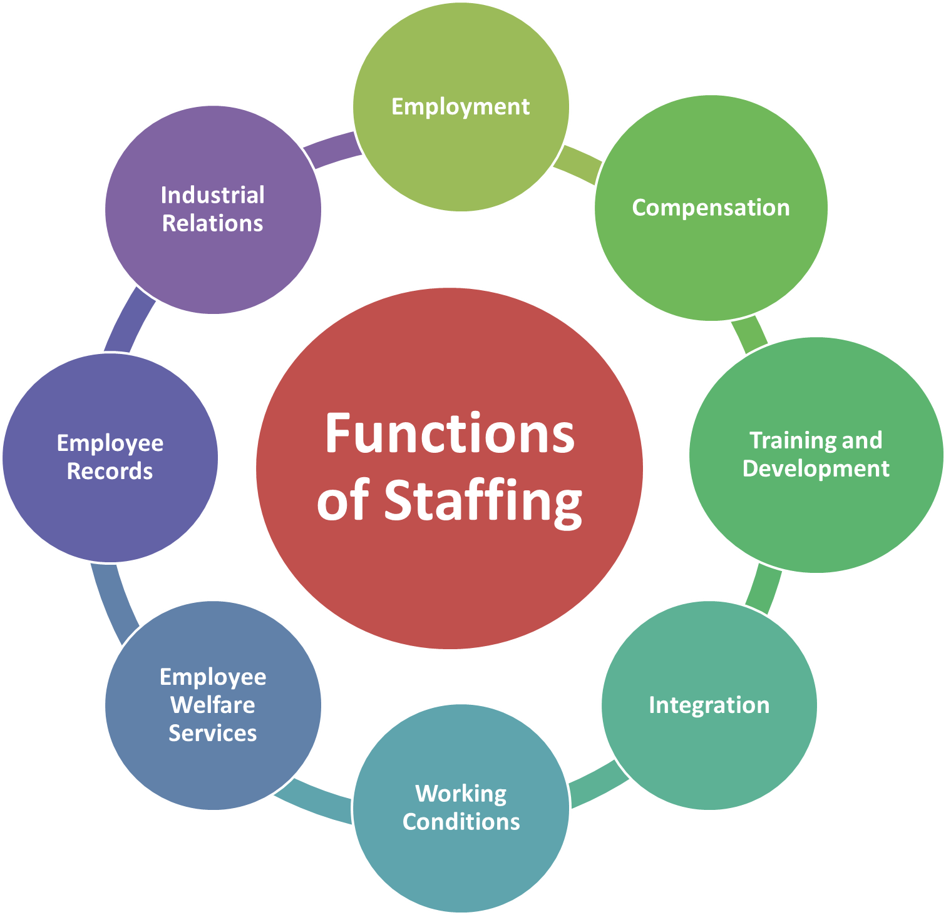

**4.1 Importance of Staffing**

Staffing is crucial for the success of any organization, including E-Sparks. There are several reasons why staffing is important in this context:

1. Achieving organizational goals: Having the right number and type of employees in place is essential for achieving the organization's goals. Without the right staff, the company may struggle to meet production targets, customer service standards, and other key performance indicators.

1. Maintaining a competitive advantage: By recruiting and hiring the best employees, E-Sparks can gain a competitive advantage over other companies in the industry. A talented and engaged workforce can help the company innovate, improve productivity, and provide better customer service.
2. Meeting legal and regulatory requirements: Staffing is also important for ensuring that the company is in compliance with laws and regulations related to human resources. This includes laws related to hiring, discrimination, and employee rights.
3. Managing costs: Proper staffing can help E-Sparks manage costs by ensuring that the company has the right number of employees to meet its needs, without having too many or too few employees.
4. Creating a positive work environment: A positive work environment can be created by having the right mix of employees, with the right skills, experience and attitude. This can lead to increased employee satisfaction and engagement, which can in turn lead to improved employee retention and reduced turnover.
5. Managing the Exit Process: Proper staffing also involves managing the Exit process, which can have a significant impact on the company's operations and morale.

Overall, staffing plays a vital role in the success of E-Sparks by enabling the organization to meet its goals, maintain a competitive advantage, comply with legal and regulatory requirements, manage costs and create a positive work environment.

**4.2 Methods of Staffing**

Recruitment refers to the process of finding and attracting qualified candidates for a job opening within an organization. The recruitment process includes a range of activities, including advertising job openings, screening resumes and applications, conducting interviews, and making final hiring decisions.

There are two most common methods:

1)-Internal Recruitment 2)-External Recruitment

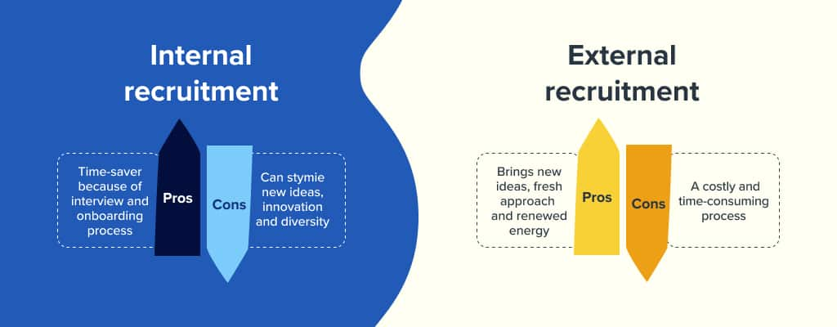

**Internal recruitment**: Internal recruitment refers to the process of looking for candidates within the organization who are already employed. This type of recruitment can be done through promotions, transfers, or lateral hires. Internal recruitment can be beneficial for an organization because it allows the company to promote from within, which can help to maintain employee morale and loyalty. Additionally, internal recruitment can be more cost-effective than external recruitment, as it does not require advertising or other recruitment-related expenses.

**External recruitment**: External recruitment refers to the process of looking for candidates outside of the organization. External recruitment can be done through advertising job openings, working with recruitment agencies, or attending job fairs. External recruitment allows an organization to access a wider pool of candidates and can be beneficial when the company needs to fill a specific skill set or experience that is not available internally. Additionally, external recruitment can help to bring fresh perspectives and new ideas to the company. But, it can be more expensive than internal recruitment as it includes advertising and other recruitment-related expenses.

Overall, the choice between internal and external recruitment will depend on the organization's specific needs and goals. For example, if the organization is looking to fill a specific skill set or experience that is not available internally, external recruitment may be the best option, while internal recruitment may be the best option if the organization wants to promote from within and maintain employee morale and loyalty.

**4.3 Selection Process**

The staff selection process can vary depending on the company's specific policies and procedures. However, a typical staff selection process may include the following steps:

1. **Job analysis and job posting:** The first step in the selection process is to conduct a job analysis to determine the specific duties, responsibilities, and qualifications required for the job. This information is used to create a job posting, which is advertised internally or externally to attract candidates.
2. **Resume screening:** The next step is to screen resumes and applications to identify candidates who meet the minimum qualifications for the job. This can be done by an HR representative or a hiring manager.
3. **Interviewing:** Candidates who pass the resume screening are then invited to participate in an interview. Interviews can be conducted in person, over the phone, or via video conferencing. The purpose of the interview is to assess the candidate's qualifications, skills, and experience to determine if they are a good fit for the job.
4. **Background and reference checks:** After the interviews, the company may conduct background and reference checks on the top candidates. This can include checking the candidate's employment history, education, and criminal record.
5. **Selection and offer:** After the background and reference checks are completed, the company will make a final selection and extend a job offer to the selected candidate.
6. **On boarding:** Once the candidate accepts the job offer, the company will begin the on boarding process to orient the new employee to the company and help them to get acclimated to their new role.

It's important to note that selection process may vary depending on the company's specific policies and procedures, and may include additional steps such as testing or evaluation centres, assessment centres, or other types of selection methods.

**4.4 Recruiting Technologies**

There are several recruiting technologies that IT organizations like this can use to streamline and improve their recruitment process. Some examples include:

* Applicant Tracking Systems (ATS): These are software systems that are designed to manage and streamline the recruitment process. They allow organizations to post job openings, track resumes and applications, schedule interviews, and make hiring decisions. Some ATS also include resume parsing technology which can automatically extract information from resumes such as contact information, education, and work experience, making it easier to manage large volumes of resumes.
* Video Interviewing: This technology allows organizations to conduct interviews remotely, via video conferencing. This can save time and money, and it allows companies to interview candidates from anywhere in the world.
* Social Recruiting: This technology allows organizations to use social media platforms such as LinkedIn, Twitter, and Facebook to find and attract candidates. This can be done by posting job openings on social media sites, or by using social media to identify and contact potential candidates.
* Chat bots: This technology can be used to automate initial screening and answer frequently asked question from candidates.
* AI-powered recruitment: This technology allows organizations to use artificial intelligence to automate and streamline recruitment tasks such as resume screening, scheduling interviews, and conducting background checks, which can save time and money.

These technologies can help organizations to be more efficient and effective in their recruitment process, and to find the best candidates for open positions.

**4.5 Factors Affecting Staffing**

There are several factors that can affect staffing in an organization like E-Sparks. These include:

1. **Organizational goals and strategy:** The Company’s goals and overall strategy will have a significant impact on staffing decisions. For example, if the company is planning to expand its operations, it will likely need to hire more employees to support that growth.
2. **Economic conditions:** Economic conditions can also affect staffing decisions. For example, during a recession, the company may need to reduce staffing levels in order to control costs
3. **Legal and regulatory environment:** Laws and regulations related to human resources can also affect staffing decisions. For example, if the company is required to comply with affirmative action regulations, it may need to take specific steps to recruit and hire a diverse workforce.
4. **Labour market conditions:** The availability and cost of labour can also affect staffing decisions. For example, if the company is located in an area with a tight labour market, it may need to offer higher salaries and other incentives to attract and retain employees.
5. **Technological changes:** Advances in technology can also affect staffing decisions. For example, if the company introduces new automation or other technology, it may need to retrain or lay off employees.
6. **Company culture and Employee engagement:** The company culture and employee engagement can also affect staffing decisions. For example, if the company culture is toxic or unhealthy, it may struggle to attract and retain employees.
7. **Employee retention:** The Company’s employee retention rate can also affect staffing decisions. If the company has a high turnover rate, it may need to re-evaluate its staffing and recruitment strategies to reduce turnover.
8. **Employee demand:** The Company’s employee demand, like the specific skills, experience and attitude required can also affect staffing decisions. For example, if the company is looking to hire employees with specific skills, it may need to offer higher salaries and other incentives to attract those employees.

Overall, staffing decisions in E-Sparks organization are affected by a range of internal and external factors that can have a significant impact on the company's ability to meet its goals and maintain a competitive advantage.

**4.6 Why Careful Selection is Important**

**Cost-effective:** Careful selection can help to minimize the costs associated with recruitment, such as advertising and hiring fees, by ensuring that the right candidate is selected the first time. This can save the organization time and money in the long run.

**Productivity:** Careful selection ensures that the right candidate is placed in the right role, which can lead to increased productivity and job satisfaction. When employees are well-suited to their roles, they are more likely to be motivated and engaged, which can lead to higher levels of performance and productivity.

**Skill match:** IT organizations have specific needs, and skills required for the job that may change frequently. Careful selection ensures that the candidate has the necessary skills, qualifications and experience to do the job effectively.

**Organization fit:** Careful selection also helps to ensure that the candidate is a good fit for the organization's culture and values, which can lead to increased employee engagement and retention.

**Legal compliance:** Careful selection can also help to ensure that the organization is in compliance with legal requirements such as equal opportunity laws, by ensuring that candidates are selected based on merit and not on factors such as race, gender, or age.

**References**

**Controlling Management in Magento Development Companies - ESPARKS**

Magento is an open-source e-commerce platform that provides businesses with a powerful, flexible, and customizable online store. Companies that rely on Magento for web development need to have a system of controlling management in place to ensure that their projects remain organized, efficient, and successful.

At ESPARKS, we believe that controlling management is key to creating successful Magento projects. We use a comprehensive system of automated processes, tools, and checks to ensure that our projects remain organized and efficient. Our extensive project management system tracks the progress of each project, and our code-review process ensures that each project is built with the highest standards of quality. Our system also allows developers to easily locate, debug, and fix potential issues.

We also strive to create a culture of collaboration and innovation. We use agile methodology to ensure that our projects remain on track and our team remains productive. We also hold regular meetings and allow developers to share their ideas and provide feedback. This creates an environment of continuous improvement and ensures that our projects are always top-notch.

Finally, we use a comprehensive system of analysis and reporting to ensure that our projects remain on track. Our system includes metrics such as time-to-launch, bug count, and customer satisfaction. These metrics are used to evaluate project performance and identify trends and issues that may need to be addressed.

At ESPARKS, we strive to create a system of controlling management that is efficient, effective, and responsive. We believe that this system is key to creating successful Magento projects, and we are committed to using it to create the best possible online presence for our clients.



The success of any business largely depends on the management, and any company that hopes to excel must establish an effective system for controlling and monitoring the management. Magento Development Company E-spark is no different and has developed an effective system for managing its operations. This report will provide an overview of E-sparks management control system, including how the company has implemented it and how it is monitored and evaluated.

**Implementation of the Management Control System**

E-spark has implemented an effective system for controlling and monitoring its management. The system is composed of a series of processes and procedures that serve to guide and regulate the management processes of the company. These processes and procedures include setting clear objectives and goals, monitoring performance, evaluating results and assessing progress.

The management control system is divided into three distinct parts: goals and objectives, performance, and evaluation. The first part of the system focuses on setting clear and achievable goals and objectives. This is done through the use of a detailed performance plan. The performance plan outlines all the metrics that will be used to measure performance and set objectives. This plan is then monitored to ensure that it is being followed.

The second part of the system is performance monitoring. This involves tracking the progress of the performance plan and taking corrective actions as needed. This is done by tracking all of the metrics outlined in the performance plan, and assessing the progress of each metric. If any of the metrics are off track, the management team can take corrective action to get the metric back on track.

The third part of the system is evaluation. This involves assessing the results of the performance plan and determining if it is successful. This is done by assessing the results and comparing them against the goals and objectives set in the performance plan. If the results are not meeting the expectations, then adjustments are made to the performance plan and the process is repeated.

**Monitoring and Evaluation of the Management Control System**

Once the management control system is in place, it must be monitored and evaluated to ensure that it is working properly. The monitoring and evaluation process is done on a regular basis. The evaluation process involves assessing the performance of the system, the results obtained, and the overall effectiveness of the system.

The evaluation process is designed to identify areas of improvement and suggest changes to the system. Any changes made to the system must be documented and tracked to ensure that they are implemented.

**LEADING AT E-Sparks :**

ESPARKS is a one of the best Magento Website Development Companies with years-long experience. They provide all kinds of services required to develop and grow your e-commerce business. From providing consultation to delivering solutions, their team of experts is always ready to assist. They believe that aesthetics are as important as functionality, and this is why ESPARKS do our best to give equal attention and time to both. Best customer services and uncompromisable quality is our strength. They pay equal attention to each of our clients and deliver the best and highly competitive business solutions. They provide custom strategies to our clients based on their business needs and goals.

Leading involves the social and informal sources of influence that you use to inspire action taken by others. If managers are effective leaders, their subordinates will be enthusiastic about exerting effort to attain organizational objectives.

Leading is all about leadership, decision making, communication and groups teams and motivation.

Leaderships at ESPRKS involves influencing others through direction, inspiration, and motivation toward the attainment of organizational objectives.

Leading is distinct from the organizing function of management, which generally includes arranging or assembling resources.

E-Sparks has been recognized among the Top Magento Development Companies in June, 2021 by[Design Rush Marketplace](https://www.designrush.com/).

Design Rush is a reliable online guide to finding the best professional companies and agencies categorized according to vertical and area of expertise.



After evaluating and analysing E-Sparks’ performance with some of the most prominent brands in the World, the online platform gave E-Sparks a spot among the Top Magento Development Companies. This all is a result of efforts and leadership abilities of senior employees of E-SPARKS.

The founder Umair Zaman has a moto to transform ideas into businesses, he has worked with start-ups and tech leads to bring new innovations, particularly in the field of E-Commerce. E-Sparks has achieved 100%success rate on Upwork & 90% client retention rate thanks to relentless pursuit of opportunity and optimization efforts.

**E-Sparks has achieved 100%success rate on Upwork & 90% client retention rate thanks to relentless pursuit of opportunity and optimization efforts.**

At E-Sparks, We have got a team of highly skilled and talented people who are the true asset of our company. Together we build good relations with our clients by delivering the best results.

Website design and development solutions provided by its Magento certified team are scalable, customer-centric, responsive, feature-packed, user friendly, and fully performing. They value their team by providing them a positive work environment so that they can work more diligently in achieving company goals.

